Here is my update of Vault Web View. It's basically a web control embedded in a Vault Explorer tab.
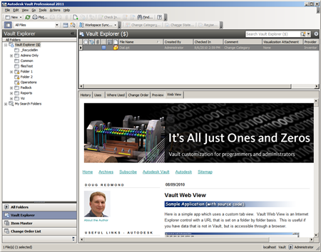
To use it, your Vault administrator sets up a Vault property which will contain the URL information. After that, whenever you select a Vault object that contains the property, the Web View tab will browse to that URL. The URL can be set and updated using Vault's property editor.

Requirements:
Vault Workgroup/Collaboration/Professional 2012
Click here to download the application
Click here to download the source code

Enhancements:
In version 1.0 a custom command was needed to set and update a folder URL. In Vault 2012, folders can have property values, so Web View was updated to use properties instead of a custom command. Version 2 also allows you to set URL data on all main entity types (files, folders, items and change orders). Lastly, you don't need to be an administrator to set the URL. Anyone who can set property data, can set the URL. I'm not sure if this is good or not, but it's a result of using Vault property data.

